Chapter 17, Problem 21.

Determine the trigonometric Fourier series of the signal in Fig. 17.59.

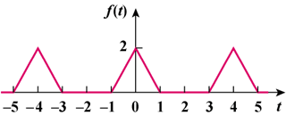

Figure 17.59
For Prob. 17.21.

